Multicast Forwarding
Scope Definition

Revision 0.1
Hui Shao
Date Last Updated Apr. 12, 04

Revision History
Date | Version | Description | Author
2004-4-12 | 0.1 | Initial draft | Hui Shao

Table of Contents

Revision History 1
1 Objective 3
1.1 Goals 3
1.2 Deliverable 4
2 Scope 4
2.1 Aggregator service or daemon 4
2.1.1 Multicast Listener 4
2.1.2 TCP Tunnel 4
2.1.3 Multicast Resender 5
2.1.4 Windows Service or Daemon 5
2.1.5 Administration and Configuration 5
2.2 Test Utilities 5
2.3 Documents 5
2.4 Training 5
3 Scope Approach 6
3.1 The layer that the Aggregator listens 6
3.1.1 UDP layer 6
3.1.2 IP layer 6
3.2 Convert connectionless-oriented traffic to connection-oriented traffic 6
3.3 Prevent Dead-Loop Traffic 7
3.4 IPv4 and IPv6 Mixing 7
3.4.1 IPv6 support 7
3.4.2 IP version mixing: 7
3.5 NT 4.0 support issues 7
4 Dependencies Summary 7
5 References 7

Objective
It is anticipated that there are environments where ITV and other applications, would like to use or need to use multicast, but may not be allowed in portions of the customer network.
For example, it maybe acceptable from the customer perspective, for an application to use multicast in a subnet, but the multicast will never be allowed past the router serving the subnet. However, the application software may need to have a multicast conversation that spans 2 or more subnets.

Goals
Build a service or daemon that will
- aggregate multicast traffic,
- forward it via a connection-oriented protocol to a receiving service or daemon
- re-multicast the traffic at the receiving service or daemon
- be able to be configured between 2 or more subnets
It is the rough equivalent of a V-LAN for multicast support.

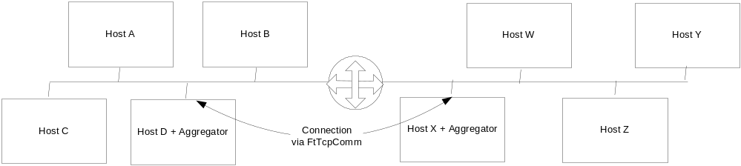
Figure 1, Small 2 Network System

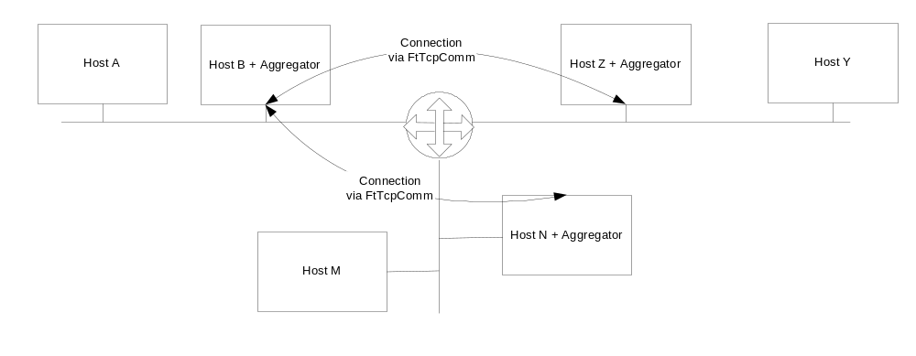
Figure 2, Medium 3 Network System
In the small 2 network system above, a collection of nodes in both networks may want to participate in 1 single multicast conversation. The aggregators in each network would be configured to listen for that conversation and forward it to the other side.
In the above 3-network system, a multicast conversation is required to traverse all three network segments. In this case the Aggregator on Hosts B, N and Z would be required to forward multicast messages on their local subnet to the other aggregators and the destined aggregator would subsequently re-multicast the received messages on their local subnet.

Deliverable
The following pieces will be delivered as part of this development effort:
- The aggregator service or daemon (including source code and project build settings)
- Test utilities
- Documents (including a user manual of aggregator)
- Training

Scope
This section gives details on each component. It breaks each component into subsections. The overview describes a component and the requirement for this component.

Aggregator service or daemon
Is the primary deliverable of this project. It has tree major interfaces: Multicast Listener, TCP tunnel, Multicast Resender. Also it must support SeaChange’s ManUtil, SNMP features and should address cross-platform distribution

Multicast Listener
The aggregator listen multicast packages through this interface. The interface must be able to
- receive UDP multicast packages on its local subnet
- handle IPv4 and IPv6 version mixing
- must filter out the package resent by its own multicast resender (2.1.3)

TCP Tunnel
One connection between any two servers must be made:
- The connection must be fault resilient by invoking MtTcpComm
- All multicast conversations between two aggregators should tunnel through a single TCP connection instead create separate TCP connections for different multicast messages/conversations
- Handle IPv4 and IPv6 version mixing
- Has a mechanism to responds the performance bottle-neck when the connectionless-oriented traffic is converted to the connection-oriented traffic

Multicast Resender
The destined aggregator would subsequently re-multicast the received messages on its local subnet through this interface:
- Resend the multicast UDP package
- Has a mechanism to work with the multicast listener (2.1.1) to prevent dead loop traffic
- Handle IPv4 and IPv6 version mixing

Windows Service or Daemon
The aggregator must be distributed as an NT service (for Windows) or daemon (for Unix-like):
- The service distribution must use the SeaChange Service Shell and App Shell

Administration and Configuration
The aggregator must:
- be configurable through the ITV configuator service
- support ManUtil and SNMP for remote management and service status

Test Utilities
The project should also provide simple utilities for testing the setup and configuration of the aggregator service. For example, the utility should have the ability to specify a conversation for a sender and receiver across one or more subnets and demonstrate the conversation is occurring with simple well-known messages. (Similar to mcastsendtest and mcastrcvtest).

TODO: add details about the utilities

Documents
The project should provide the following documents:
- A user manual on the aggregator service and its test utilities
- Development plan (owned by ZQ, reviewed by Maynard team)
- Design documents (owned by ZQ, reviewed by Maynard team)
- Test plan (owned by ZQ, reviewed by Maynard team)

Training
Training should be provided by ZQ when the project is delivered to Maynard.
TODO: add details about the training

Scope Approach
This section only exists in the initial draft to address the key techniques or possible solutions, it should be removed after formalize the scope definition.

The layer that the Aggregator listens
The implementation of the multicast listener (2.1.1) could have two choices on the layer it listens at:

UDP layer
Advances:
- easy to implement, natively supported in Socket APIs
- low technical risk;
Disadvances:
- has to have one configuration low for each IP/port combination, maybe has to maintain a big runtime table, low performance
- hard to manage and against the minimal configuration requirement
- hard to address the reservation for the multicast-related protocol such as IGMP

IP layer
Advances:
- easy to use, minimal configuration
- high performance
- can reserve for IGMP etc.
Disadvances:
- uses the technique of raw socket that is not supported in NT 4.0 and IPv6
- high technical risks if have to work on device driver development

Convert connectionless-oriented traffic to connection-oriented traffic
When the traffic is forwarded from the multicast listener to the tunnel, a traffic bottle-neck problem will be raised since the traffic bandwidth on a connection-oriented protocol is less than that on a connectionless-oriented protocol under same network condition.
The possible solutions for this problem could be:
- Limits the listener(2.1.1) to listen specified traffic to lower the multicast traffic for forwarding
- Drop some multicast message when the traffic bottle-neck happens. A algorithm how to select the message to drop is required here

Prevent Dead-Loop Traffic
When a destined aggregator re-multicast a message through its resender interface (2.1.3), the message may be caught by its own listener (2.1.1) all other aggregator on same subnet, it could be forwarded to the source aggregator again and cause a dead-loop traffic.
A possible solution on this problem is:
The aggregator only forwards the messages with TTL (time to live) >1; meanwhile, it always set TTL=1 when it do re-multicasting. The disadvance is that forwarding among n subnets will requires n*(n-1)/2 tunnels.

IPv4 and IPv6 Mixing

IPv6 support
- IPv6 will hardly be supported on Windows NT4.0
- The technique of raw socket (see also: 3.1.2) is unavailable in Windows IPv6 support currently, which may make the aggregator difficult to listen on IP layer

IP version mixing:
TODO: under research…

NT 4.0 support issues
The NT 4.0 support issues have already been mentioned in many other sections, the following is a summary:
- Unable to address a way to listen on IP layer (see also 3.1)
- Unable to address an available IPv6 support (see also 3.4.1)

Non-Windows OS support
TODO: under research…

Dependencies Summary
Maynard team must
- formalize the requirement concerning the raised issue in this document
- decide the listen layer (3.1) and the message dropping policy (3.2)
- confirm the TTL solution for dead-loop traffic (3.3), or give another solution
- decide the listen layer for IPv6
- give a training on SeaChange’s svcshell, appshell (2.1.4), MtTcpComm(2.1.2) and ManUtil/SNMP support(2.1.5)
ZQ must
- complete the IP version mixing research and give a report
- complete the non-windows support research and give a report
- provide more possible solutions on the raised issues

References
- Multicast Forwarding Requirements by Mike Kiskiel
- Unix Network Programming Volum1 Networking APIs: Sockets and XTI(second edition) by W. Richard Stevens
- Network Programming for Microsoft Windows by Anthony Jones
- ms-help://MS.MSDNQTR.2003FEB.2052/winsock/winsock/multicast_programming.htm
- ms-help://MS.MSDNQTR.2003FEB.2052/winsock/winsock/tcp_ip_raw_sockets_2.htm
- ms-help://MS.MSDNQTR.2003FEB.2052/winsock/winsock/ipv6_guide_for_windows_sockets_applications_2.htm

